User Manual

1 )To begin you have to go to the registration page which can be found at localhost:8080/register
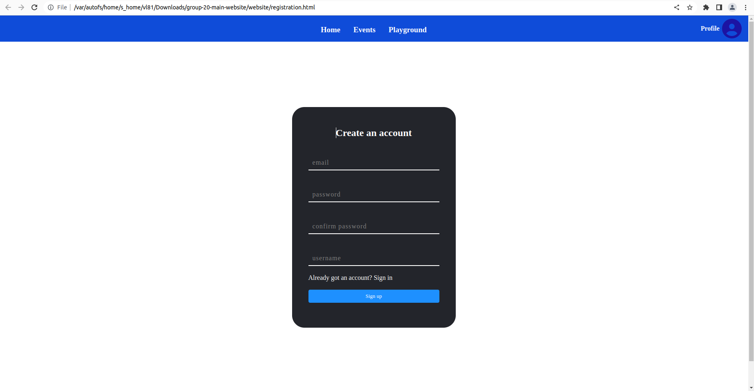
2) Enter your email and password and confirm the password. Also enter your username and click sign up.

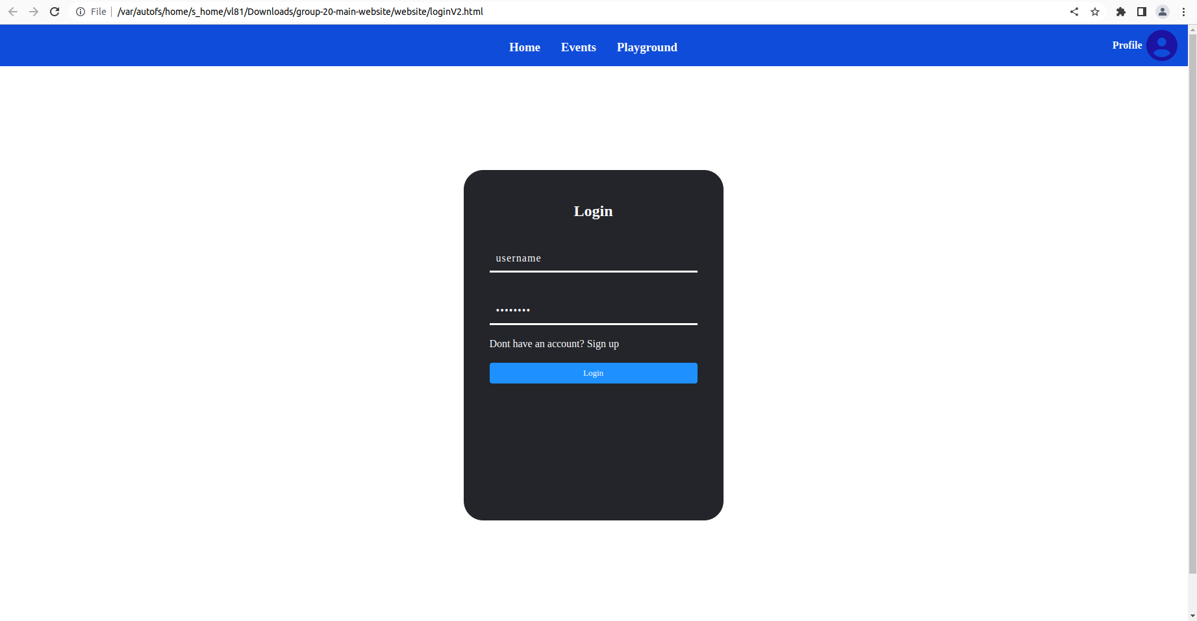
3) Enter the URL localhost:8080/login to enter login page.

4) Enter username and password and click login.

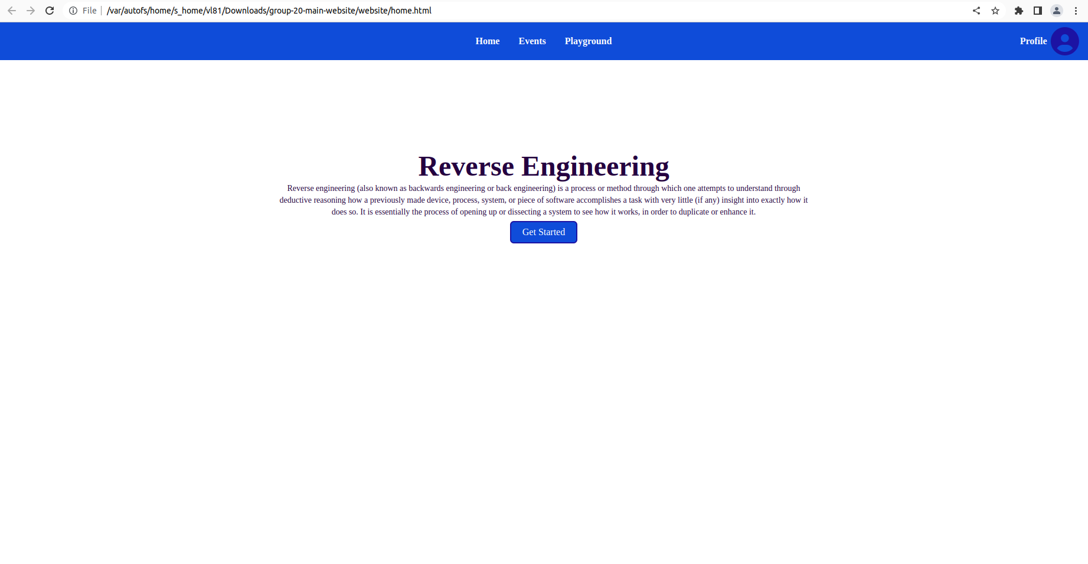
5) You should be redirected to the homepage.

6) Here is the main page for the prototype. There will be new functionalities added soon.

